
Software Engineering Department
Braude College of Engineering
Final Project – Phase A (61998)

Adaptive Virtual Reality Museum: A Closed-Loop Framework for Engagement-Aware Cultural Heritage

CODE: 26-1-D-23
Joseph Damouni
Wadea Tannous

Advisor:
Dr. Naomi Unkelos Shpigel

Link to GitHub:
https://github.com/JosephDamouni/Project_Phase-A.git

ABSTRACT
- INTRODUCTION ………………………………………………………………………………..4
  - Motivation………………………………………………………………………………...4
  - The Hardware-Software Gap in VR…………………………………………………...4
  - Project Overview………………………………………………………………………...4
- BACKGROUND AND RELATED WORK ……………………………………………………..5
2.1 The Challenge of Visitor Heterogeneity………………………………………………5
2.2 State of the Art: Static VR Environments……………………………………………..5
2.3 Behavioral Signal Processing in HMDs……………………………………………….5
2.4 Generative AI in Education…………………………………………………………….5
2.5 Gap Analysis and Project Focus………………………………………………………6
- PROPOSED SYSTEM DESIGN ………………………………………………………………6
3.1 System Overview………………………………………………………………………..6
3.2 Functional Requirements……………………………………………………………….7
3.3 Non-Functional Requirements…………………………………………………………8
3.4 Use Case Analysis………………………………………………………………………8
3.5 Engagement Classification Design ……………………………………………...……9
3.5.1 Input Signals………………………………………………………………….9
3.5.2 Score Aggregation………………………………………………………….10
3.5.3 Temporal Smoothing and Safety Gates………………………………….11
3.5.4 Threshold Mapping to Engagement Levels……………………………...12
3.6 Content Adaptation Design …………………………………………………….….…13
3.6.1 Runtime LLM Generation Strategy………………………………….….…13
3.6.2 Caching Mechanism………………………………………………………..13
3.6.3 LLM Prompt Strategy…………………………..…………………….….…14
3.7 Museum Environment Design…………………………………………….………….14
3.8 Activity Diagram……………………………………………………………………..…15
- I IMPLEMENTATION APPROACH ………………………………………………….……16
4.1 Development Methodology ……………………………………………………..……16
4.1.1 Development Tools and Frameworks……………………………….……16
4.2 System Implementation ……………………………………………….………...……16
4.2.1 Sensing and Inference Pipeline………………………………..…….……16
4.2.2 Asynchronous Content Pipeline…………………………………………..16
4.3 Technical Validation………………………………….………………………………..17
4.4 Anticipated Challenges and Mitigations …………………….…………………...…17
- EVALUATION METHODOLOGY ……………………………………………………………18
5.1 Research Questions…………………………………………………………………..18
5.2 Study Design…………………………………………………………………………..18
5.3 Participants…………………………………………………………………………….19
5.4 Procedure………………………………………………………………………………19
5.5 Measures……………………………………………………………………………….19
5.6 Preliminary Results……………………………………………………………………19
- PROJECT PLANNING …………………………………………………………………….….20
6.1 Completed Milestones……………………………………………………………..….20
6.2 Phase B Planned Work……………………………………………………………….21
- EXPECTED ACHIEVEMENTS …………………………………………………………….…21
7.1 Technical Contributions…………………………………………………………….…21
7.2 Research Contributions…………………………………………………….…………21
7.3 Practical Impact………………………………………………………..………………22
- CONCLUSION……………………………………..………………………………………...…22

ABSTRACT
This project presents an adaptive VR museum system that is designed to classify visitor engagement during exploration and adjust exhibit text length accordingly. The system captures four behavioral signals through Meta Quest 3 sensors: gaze dwell time, head angular velocity, locomotion speed, and reading text dwell time. Signals are sampled at frame rate and aggregated over multi-second windows using weighted scoring, applying temporal smoothing and velocity-based safety gates to classify engagement into five discrete states (Highly Disengaged to Highly Engaged). Based on the inferred engagement state, the system generates content through runtime LLM calls (GPT-3.5-turbo), with word count adapted to engagement level and a 5-minute caching mechanism to optimize API usage.

1. INTRODUCTION
1.1 Motivation
The Challenge at Berat Ethnographic Museum
The Berat Ethnographic Museum preserves 19th-century Ottoman life and serves a mixed audience of local Albanian residents and international tourists. This visitor diversity creates a content delivery conflict: static text that satisfies a historian often overwhelms a casual tourist, while simplified summaries frustrate users seeking depth. Physical museums address this through human guides who adapt explanations to visitor behavior. However, digital reconstructions and VR adaptations typically lack this adaptability, relying on "one-size-fits-all" information panels that force all users to consume identical content regardless of their demonstrated interest level.
1.2 The Hardware-Software Gap in VR
Modern VR hardware, specifically the Meta Quest 3, captures high-fidelity behavioral data including head orientation, head-gaze direction via raycasting, and positional tracking. However, current cultural heritage applications rarely use this data stream for content adaptation. Most existing VR museums function as static 3D environments: they render 3D spaces but deliver information through fixed UI elements. This approach ignores implicit user signals. If a user leans in to examine details or dwells on an object, the system remains unresponsive. This disconnect between hardware capabilities (rich sensor data) and software implementation (static content) represents a limitation in current implementations to support adaptive information delivery provided by human curators.
1.3 Project Overview
This project presents a behavior-adaptive VR system for the Berat Ethnographic Museum. The system continuously aggregates headset-based behavioral signals, including head-gaze dwell via raycasting, head motion stability, locomotion patterns, and reading behavior. Using rule-based thresholds and safety gating, it classifies engagement level continuously during exploration. When the visitor requests information, the system generates exhibit descriptions at runtime via OpenAI API calls. A time-bounded caching mechanism (5-minute expiry) reduces redundant requests and improves responsiveness during repeated interactions.
This work extends a static VR museum environment developed with Sokol (Tirana University, Albania). Phase A contributions include: (1) real-time engagement classification from behavioral signals, (2) runtime LLM content adaptation with caching, and (3) preliminary user validation (N=16). The goal is to evaluate whether engagement-aware content delivery can increase session duration and content consumption compared to a static VR baseline.
2. BACKGROUND AND RELATED WORK
2.1 The Challenge of Visitor Heterogeneity
Museums face a fundamental design conflict: their audience is heterogeneous. Empirical studies [1,2] indicate that visitors vary significantly in prior knowledge and dwell time. Some seek "skimming" experiences (low dwell time, high breadth), while others engage in "deep diving" (high dwell time, focused depth). Physical museums address this through human curators who adapt narratives to visitor behavior. However, digital preservation efforts often fail to replicate this adaptability. Most digital heritage applications present "one-size-fits-all" content, delivering identical text and audio to all users [3]. This lack of personalization is cited as a contributing factor in the engagement drop-off observed in digital museum tours compared to guided physical tours [4].
2.2 State of the Art: Static VR Environments
Virtual Reality (VR) is widely used for cultural heritage to reconstruct lost or inaccessible sites, such as Rome Reborn or the Virtual Museum of Iraq [3]. These applications succeed in visual fidelity (photorealistic textures, accurate geometry) but fail in narrative flexibility. Technically, these systems rely on pre-baked assets and static UI canvases. The information architecture is hard-coded; a user looking at an artifact for 10 seconds receives the same feedback as a user looking for 1 second. Current literature describes these as "Static Virtual Environments" (SVEs), which do not respond to the user's implicit behavioral cues.
2.3 Behavioral Signal Processing in HMDs
Modern Head-Mounted Displays (HMDs), such as the Meta Quest 3 planned for this project, provide continuously sampled sensor data that correlate with engagement.
- Gaze Duration: Extended gaze on specific Areas of Interest (AOI) correlates with cognitive interest [5, 6].
- Head Stability: Reduced head movement velocity is a marker of focus/reading, while erratic movement suggests scanning or disinterest [7].
- Proxemics: The physical distance a user maintains from a virtual object mimics social engagement rules in physical spaces [8]. Despite the availability of these signals via APIs like OpenXR, few commercial museum applications integrate them into a real-time feedback loop.

2.4 Generative AI in Education
Recent advancements in Large Language Models (LLMs) enable the dynamic generation of educational content. Adaptive learning systems have begun utilizing LLMs to simplify or expand text based on student proficiency [9]. However, integrating LLMs into VR presents latency challenges. Real-time generation can introduce delays that break immersion. Therefore, a hybrid approach using LLMs at runtime with caching mechanisms to balance dynamic content generation with acceptable latency presents a more viable architectural path for latency-sensitive VR environments.
2.5 Gap Analysis and Project Focus
A gap exists between high-fidelity sensor capabilities and static content delivery in VR museums.
- Existing VR museums are visually immersive but narratively static.
- Adaptive learning systems exist on the web but are rarely ported to immersive VR.
- There is a lack of localized, adaptive solutions for Balkan/Ottoman heritage sites like the Berat Ethnographic Museum.
This project addresses this gap, the proposed system will design a feedback loop that uses the behavioral signals described in Section 3.3 to trigger the content variants described in Section 3.4, specifically tailored for the Berat context.

3. PROPOSED SYSTEM DESIGN

3.1 System Overview

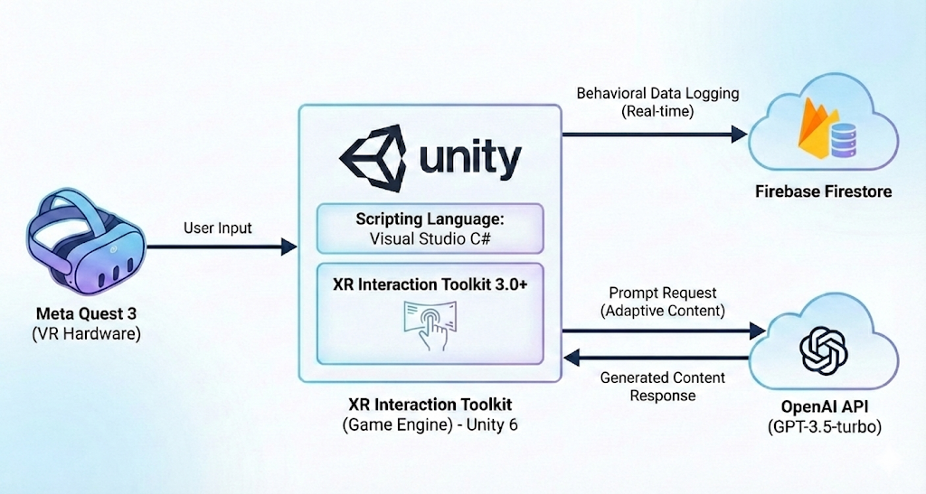
The Adaptive VR Museum System uses a three-tier architecture connecting VR hardware, a game engine processing layer, and cloud-based services. Figure 1 presents this architecture.

Figure 1: System Architecture Diagram Three-tier architecture showing data flow from Meta Quest 3 sensors through Unity processing to Firebase logging and OpenAI content generation.
The Meta Quest 3 headset serves as the primary input device, capturing user behavioral signals through its onboard sensors. These signals include head-gaze direction via head-oriented raycasting, head rotation and angular velocity measured by the internal inertial measurement unit (IMU), and positional tracking used to estimate locomotion speed. In addition, the system monitors reading behavior when content panels are displayed. Sensor data are sampled by the Unity 6 game engine running the museum application and aggregated for real-time engagement analysis. The Unity application, built with the XR Interaction Toolkit 3.0+, functions as the central processing hub. It performs three concurrent operations: rendering the virtual museum environment, processing incoming sensor data through the engagement classification pipeline, and managing communication with external services. The application logic is implemented in C# within Visual Studio.
Two cloud services support the system. Firebase Firestore receives real-time behavioral data logs, storing session information, engagement classifications, and interaction events for research analysis. The OpenAI chat-based LLM handles content generation requests at runtime, producing text adapted to the visitor's current engagement level. A 5-minute caching mechanism stores recently generated content to optimize API usage while maintaining responsive delivery.
This architecture separates concerns effectively: the headset handles sensing, Unity handles processing and presentation, Firebase handles persistence, and the LLM handles content generation. The modular design allows independent testing and replacement of components without system-wide changes.
3.2 Functional Requirements
Requirements were derived from three sources: the museum context, which motivated adaptive content for diverse visitors (FR3); hardware constraints of the standalone Meta Quest 3, requiring local sensing and classification (NFR1, NFR2); and discussions with Sokol regarding the existing six-room layout and free navigation design (FR4). No end-user interviews were conducted in Phase A; validation is addressed through the user study in Section 5.
FR1 - Behavioral Signal Capture: The system shall continuously capture four behavioral signals: gaze dwell time, head angular velocity, locomotion speed, and reading text dwell time.
FR2 - Engagement State Estimation: The system shall classify user engagement in real-time into five levels (Highly Disengaged, Disengaged, Neutral, Engaged, Highly Engaged) based on aggregated sensor data.
FR3 - Dynamic Content Adaptation: The system shall dynamically adjust content length based on engagement level using runtime LLM generation with 5-minute caching.
FR4 - Free Navigation: The system shall allow users to freely explore all museum rooms without predetermined paths or sequences.

3.3 Non-Functional Requirements
NFR1 - Performance: Engagement updates within 2 seconds; minimum 72 fps on Quest 3.
NFR2 - Portability: Runs standalone on Meta Quest 3 without PC connection.
NFR3 - Scalability of Content: New exhibits require only component attachment and configuration, no code changes.
NFR4 - Usability: No training required; all interactions are implicit through gaze and natural movement.
3.4 Use Case Analysis
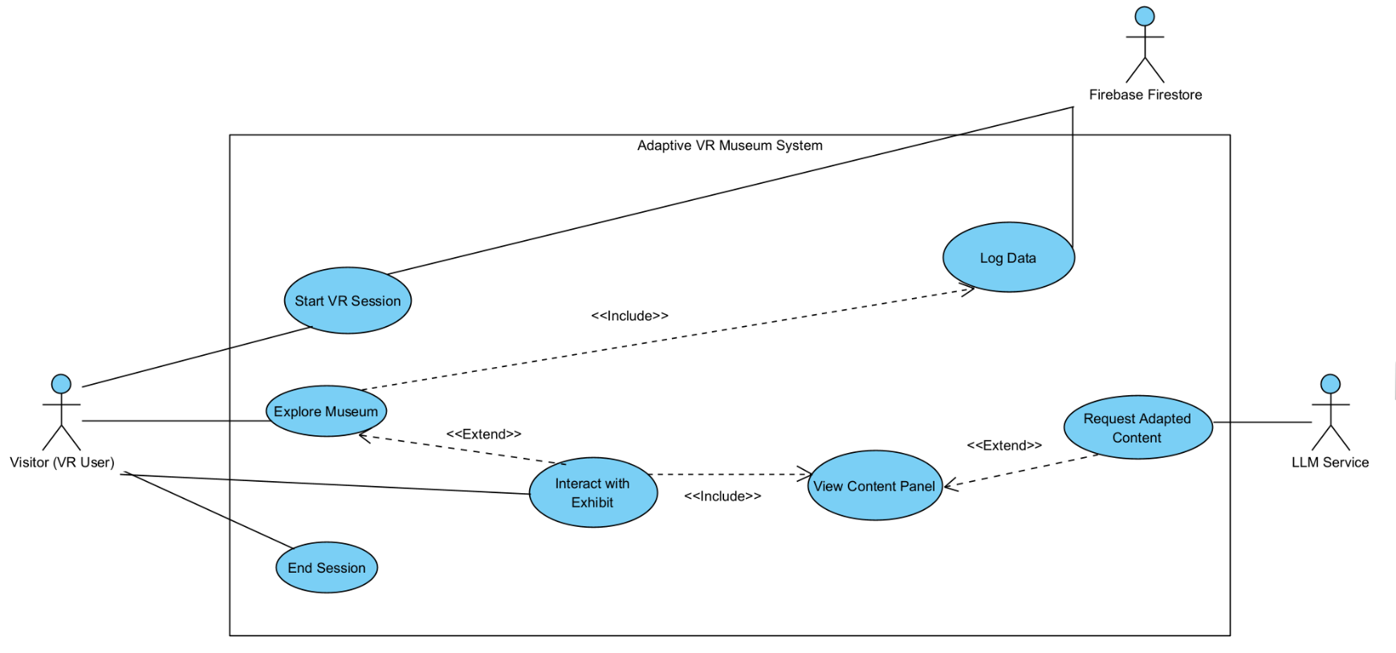
The system involves three actors interacting with seven use cases that capture the main functional interactions of the adaptive VR museum. Figure 2 presents the use case diagram.

Figure 2: Use Case Diagram System actors and use cases illustrating visitor interactions, Firebase logging, and LLM content requests.
The Visitor (VR User) serves as the primary actor, initiating sessions and driving all exploration behavior. Firebase Firestore acts as an external system actor receiving logged data. The LLM Service acts as an external system actor providing adapted content.
The Visitor directly initiates four use cases: Start VR Session begins the experience and initializes tracking systems; Explore Museum represents the core navigation activity; Interact with Exhibit allows detailed engagement with specific artifacts; End Session terminates tracking and finalizes data logging.
Interact with Exhibit extends Explore Museum, activating when the visitor demonstrates focused attention on a specific artifact. This extension is optional; visitors may explore without triggering detailed interactions. View Content Panel is included by Interact with Exhibit, meaning that every interaction results in content display.
Request Adapted Content extends View Content Panel conditionally. When a content panel is triggered and no compatible cached variant exists, the system requests new content from the LLM. Log Data is included by Explore Museum, indicating that behavioral logging occurs continuously throughout exploration. Firebase Firestore receives this data stream for persistence and analysis.
3.5 Engagement Classification Design
The engagement classification system processes four input signals and outputs one of five engagement levels. The pipeline samples signals at frame rate, normalizing and aggregating them into composite scores before applying safety gates and threshold mapping. This section describes the signal processing pipeline and decision logic.
3.5.1 Input Signals
The system collects four behavioral signals from Meta Quest 3 hardware, each processed independently before aggregation.
Figure 3a presents the signal collection and processing pipeline. It shows how the four behavioral signals gaze dwell time, head angular velocity, locomotion velocity, and reading text dwell are sampled at frame rate, normalized independently, and converted into intermediate engagement scores prior to aggregation.
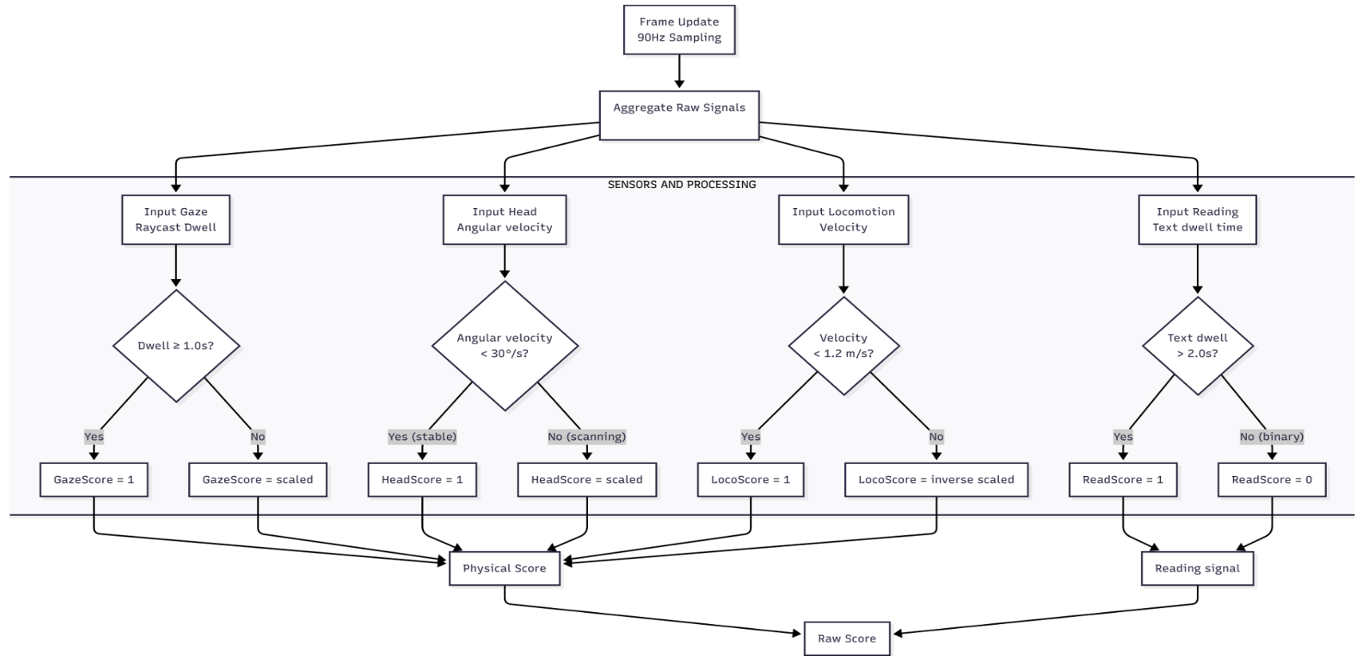

Figure 3a: Signal Collection and Processing Pipeline Four behavioral signals (gaze, head velocity, locomotion, reading) processed at 90Hz into normalized engagement scores.
Signal 1 (Head-Gaze Raycast Dwell): The system estimates visual attention using head-gaze direction via head-oriented raycasting. A forward ray is cast from the headset orientation, and intersections with exhibit colliders are tracked over time. Dwell time accumulates while the ray remains on a single exhibit.
Signal 2 (Head Angular Velocity): The IMU provides head rotation velocity in degrees per second. Low velocity indicates stable viewing; high velocity suggests scanning or transition movement.
Signal 3 (Locomotion Velocity): Positional tracking calculates movement speed in meters per second. Low velocity indicates stationary or slow movement; high velocity suggests rapid transit.
Signal 4 (Reading Text Dwell): When content panels are displayed, the system tracks gaze remaining on text elements.
3.5.2 Score Aggregation
The four physical scores combine into a composite measure through weighted aggregation:
Physical Score = (0.30 × GazeScore) + (0.35 × HeadScore) + (0.35 × LocoScore)
Reading behavior is integrated as a fifth signal with separate weighting:
Raw Score = (0.75 × PhysicalScore) + (0.25 × ReadingScore)
The initial weighting values were selected based on pilot testing, developer observation, and relative signal reliability reported in prior VR and HMD engagement literature [5–8], and are treated as configurable design parameters to be empirically refined during Phase B evaluation.
UI Occlusion Compensation: When a user reads content for 2+ seconds, the text panel occludes the exhibit collider, causing the gaze raycast to miss the object. To prevent this from being misclassified as disengagement, the system treats sustained reading as valid evidence of gaze focus and boosts GazeScore to 1.0 during active reading.
3.5.3 Temporal Smoothing and Safety Gates
Raw Score passes through temporal smoothing followed by velocity-based safety gates.
Temporal Smoothing:
Smoothed Score = Lerp(previous, raw, 0.35)
A new classification must persist for approximately 1.5 seconds before triggering a level change.
Reading Grace Period:
To allow natural repositioning while reading (e.g., adjusting position in front of wall-mounted panels), movement gates are disabled for 3 seconds after reading stops. The system tracks recentlyReading = true if the user is currently reading OR stopped reading within the last 3 seconds.

Safety Gates (evaluated in priority order):
- Run Gate (v > 2.0 m/s): If speed exceeds 2.0 m/s AND user is not recently reading, cap at Disengaged.
- Locomotion Gate (v > 1.2 m/s): If speed exceeds 1.2 m/s AND user is not recently reading, cap at Neutral.
- HighlyEngaged Gate: Requires sustained reading (2+ seconds) OR very high score (>0.75) OR recent reading with good score (>0.6).
Figure 3b presents the temporal smoothing and safety gate mechanism applied to the aggregated engagement score. The diagram highlights how smoothed scores pass through velocity-based gates to prevent false engagement classification during rapid movement or repositioning, before being mapped to discrete engagement levels.
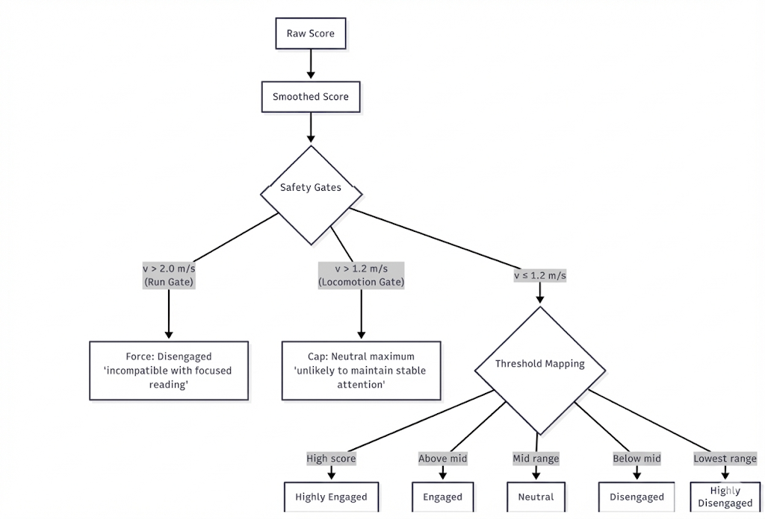

Figure 3b: Temporal Smoothing and Safety Gates Smoothed scores pass through velocity-based safety gates before mapping to five engagement levels.
If recently reading, movement gates are bypassed to prevent false disengagement from repositioning movements.
3.5.4 Threshold Mapping to Engagement Levels
When velocity is below 1.2 m/s (passing both safety gates), the Smoothed Score maps to one of five engagement levels through threshold comparison:
Level 1 - Highly Disengaged: Score in lowest range or forced by Run Gate. User is moving rapidly or showing no engagement indicators.
Level 2 - Disengaged: Score below mid-range threshold. User shows minimal attention to current exhibit.
Level 3 - Neutral: Score in mid-range or capped by Locomotion Gate. User demonstrates moderate, non-committal attention.
Level 4 - Engaged: Score above mid-range threshold. User shows sustained gaze, stable head position, and slow or no movement.
Level 5 - Highly Engaged: Score in highest range. User demonstrates all positive engagement indicators including active reading behavior.
These threshold values represent initial design parameters subject to calibration during Phase B user testing.
3.6 Content Adaptation Design
3.6.1 Runtime LLM Generation Strategy
The system uses a language model (GPT-3.5-turbo) to generate exhibit text when content is requested. When a visitor triggers a content panel, the system calculates target word count from the current engagement level and sends a generation request to the LLM. A time-based caching mechanism prevents redundant API calls. Engagement level maps to specific word count ranges:

Table 1 presents the mapping between engagement levels and target content length.
Level | Engagement State | Target Word Count | Content Purpose
1 | Highly Disengaged | 10–15 | Single attention-grabbing sentence intended to re-capture interest
2 | Disengaged | 30–50 | Short introductory paragraph highlighting a key fact or concept
3 | Neutral | 80–120 | Standard museum description providing essential contextual information
4 | Engaged | 150–200 | Detailed explanation including historical context and functional details
5 | Highly Engaged | 250–350 | Extended in-depth description for users demonstrating sustained interest

This table defines how the system translates inferred engagement states into target word count ranges in order to adapt content depth to the visitor’s observed level of interest.
3.6.2 Caching Mechanism
To reduce API usage and improve response latency, the system implements local caching with 5-minute expiry using composite keys (exhibit ID + engagement level). When content is requested:
- The system checks if cached content exists for this exhibit at a compatible engagement level.
- If valid cache exists, content is returned immediately (sub-100ms response).
- If no cache or cache expired, the system calls the OpenAI API and stores the result.
This approach balances dynamic, engagement-responsive content with practical performance requirements for VR environments.
3.6.3 LLM Prompt Strategy
Content generation uses structured prompts with explicit constraints. The system prompt establishes the LLM as a museum guide with strict word count compliance. The user prompt includes artifact name and description, target word count, and engagement-specific instructions.
Example prompt structure for Neutral:
System: You are a knowledgeable museum guide. Generate descriptions with
exact word counts. Maintain factual accuracy based on provided information.
User: Generate a 100-word description of [Ottoman Coffee Pot, 19th century,
used in traditional Albanian hospitality rituals]. Focus on cultural significance and historical context.
3.7 Museum Environment Design
The virtual environment recreates six rooms from the Berat Ethnographic Museum, each representing a distinct aspect of traditional Albanian life:
Room 1 (Traditional Dwelling): Showcases domestic architecture and living arrangements of Ottoman-era Albanian households.
Room 2 (Textile and Crafts): Displays traditional weaving, embroidery, and craftwork specific to the Berat region.
Room 3 (Agricultural Tools): Features implements used in rural Albanian life, illustrating farming practices.
Room 4 (Cultural Ceremonies): Presents objects associated with weddings, festivals, and religious observances.
Room 5 (Traditional Clothing): Exhibits regional costume variations showing differences between urban and rural dress.
Room 6 (Ottoman Period Artifacts): Highlights historical objects demonstrating cultural exchange during Ottoman rule.
Each room contains 3-5 primary exhibits with full content adaptation support, plus environmental details that enhance authenticity without requiring interaction tracking.
3.8 Activity Diagram
Figure 4 presents the activity diagram of the adaptive VR museum system, illustrating the system’s operational flow.
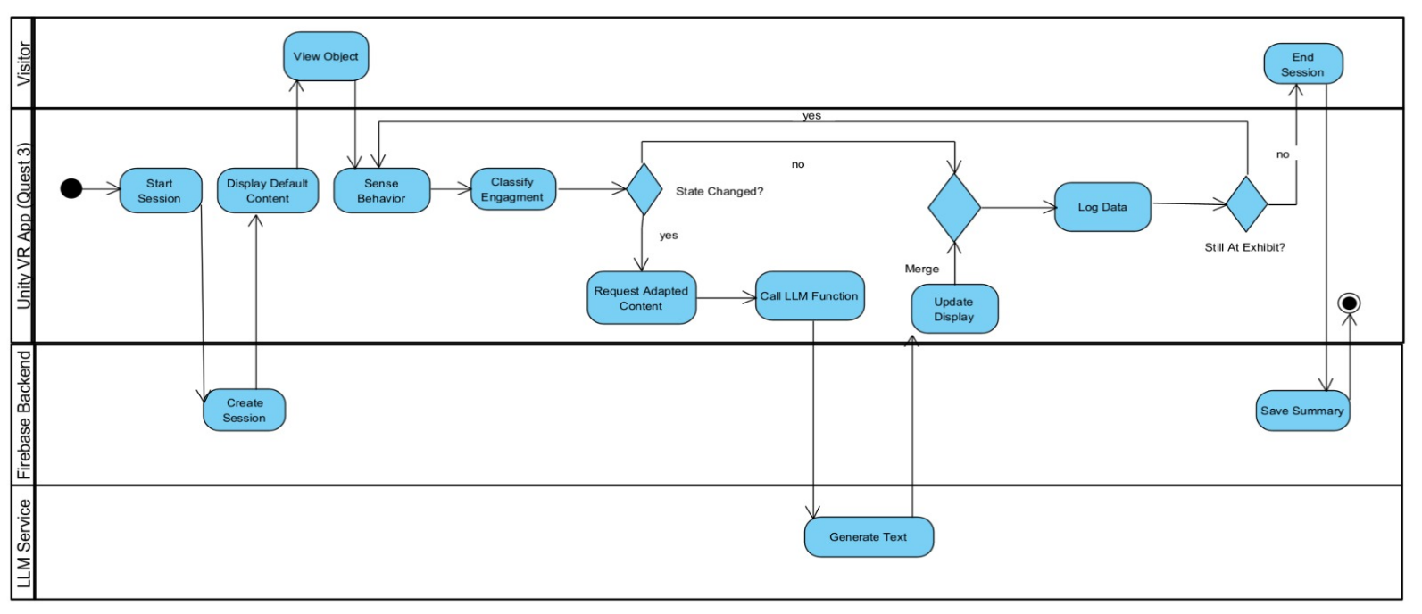
Figure 4: Activity Diagram System operational flow from session start through continuous signal collection, classification, and adaptive content delivery.
The diagram illustrates three concurrent swim lanes: Visitor Actions, System Processing, and External Services. The flow begins when the visitor starts a session, triggering initialization of tracking systems. During exploration, the system continuously collects behavioral signals and classifies engagement in real time. When content is requested and no suitable content variant is available, the system issues a request to the LLM and updates the display accordingly. Throughout the session, behavioral data is logged to Firebase for persistence and later analysis. The process concludes when the visitor explicitly ends the experience or removes the headset.
4. IMPLEMENTATION APPROACH
4.1 Development Methodology
The project follows an iterative development methodology with incremental integration of system components. Development proceeds through focused implementation cycles, each producing testable functionality that builds upon previous work.
Development is organized into four sequential phases: environment construction, behavioral tracking implementation, engagement classification development, and content system integration. Each phase concludes with internal testing before proceeding to the next.
Phase A implemented the core system described in Section 3. The full museum environment (six rooms, exhibit assets, navigation mechanics) was inherited from the baseline implementation developed with Sokol. Phase A contributions focus on the adaptive layer: engagement classification pipeline and runtime LLM integration.
4.1.1 Development Tools and Frameworks
Table 2 summarizes the main development tools, technologies, and platforms used to implement the adaptive VR museum system.
Component | Tool / Technology | Purpose
Game Engine | Unity 6 | Core application development and VR rendering
XR Framework | XR Interaction Toolkit 3.0+ | VR interaction handling and device abstraction
Target Hardware | Meta Quest 3 | Standalone VR deployment platform
IDE | Visual Studio 2022 | C# scripting and debugging
Backend Database | Firebase Firestore | Real time data logging and session storage
Content Generation | OpenAI API (GPT 3.5 turbo) | Runtime adaptive content generation
Version Control | Git | Source code management

4.2 System Implementation
4.2.1 Sensing and Inference Pipeline
Signal acquisition occurs within Unity's update and physics loops. Gaze is approximated via forward raycasting against exhibit colliders, while head kinematics and locomotion velocity derive from pose deltas of the CenterEyeAnchor and CameraRig transforms. The engagement inference engine applies temporal smoothing and safety gates before updating the global state machine.
All core interaction loops behavioral sensing, signal aggregation, and engagement inference execute locally on the Snapdragon XR2 Gen 2 processor for low-latency performance.
4.2.2 Asynchronous Content Pipeline
Content adaptation is decoupled from the rendering thread to prevent frame stalls. When a content panel is triggered, the system determines the current engagement level and, if needed, issues an asynchronous request to the OpenAI API. Generated explanations are cached using a composite key (exhibit ID + engagement level), enabling instant retrieval during revisits and reducing network overhead.

4.3 Technical Validation
The following table summarizes the key performance metrics used to validate system behavior under runtime conditions.
Table 3 presents the technical performance validation results of the implemented system.
Metric | Target | Achieved
Engagement Inference Latency | < 500 ms | < 0.2 ms
Frame Rate | ≥ 72 fps | 72+ fps maintained
Content Delivery (cached) | < 100 ms | Sub 100 ms
Content Delivery (API call) | < 3 s | 1–2 s typical

Latency values were measured on Meta Quest 3 under typical runtime conditions during controlled test sessions.
4.4 Anticipated Challenges and Mitigations
This section outlines key technical and design challenges anticipated during deployment and describes the mitigation strategies adopted in Phase A or planned for Phase B.
Challenge 1: LLM Content Accuracy
GPT-3.5-turbo may generate historically inaccurate or fabricated details, as it has no inherent ground-truth knowledge of specific Berat Museum artifacts.
Mitigation:
All prompts include verified base content authored by museum domain experts and explicitly instruct the model to avoid speculation. Generated content is manually reviewed prior to deployment. Prompts include the instruction: “Do not invent historical details. If information is not provided, state only what is given.”
Challenge 2: API Latency
Runtime LLM calls introduce 1–2 second delays, which may disrupt immersion in VR environments.
Mitigation:
A caching mechanism (Section 3.6.2) eliminates latency for repeated visits to the same exhibit at the same engagement level. For first-time requests, a loading indicator is displayed instead of blocking the interface. Phase B will explore pre-generation of common exhibit–engagement combinations.
Challenge 3: Motion Sickness Risk
Continuous locomotion at higher speeds may cause discomfort due to visual–vestibular mismatch.
Mitigation:
Both teleportation and continuous locomotion modes are supported. Engagement classification is based on positional change over time rather than input method, ensuring consistent behavior across movement styles.
Challenge 4: Threshold Calibration
Initial engagement thresholds are based on literature and developer testing and may not generalize across all users.
Mitigation:
Phase B will collect data from a larger participant pool (target N=40) to refine threshold values. Thresholds are configurable parameters, enabling adjustment without code changes. Adaptive or per-user calibration may be explored if systematic misclassification is observed.
Challenge 5: False Disengagement During Reading
When users read wall-mounted panels, they often reposition, and the UI panel can occlude the exhibit collider, causing the gaze raycast to miss. Both effects can lead to false disengagement classification.
Mitigation:
Two mechanisms address this: (1) UI occlusion compensation sets GazeScore to 1.0 during sustained reading, and (2) a 3-second reading grace period disables movement gates after reading, allowing repositioning without triggering disengagement.

5. EVALUATION METHODOLOGY
5.1 Research Questions
This project investigates the question: Does engagement-driven content adaptation in a VR museum improve the user experience compared to a static VR museum?
RQ1: To what extent can implicit behavioral signals reliably estimate visitor engagement in real-time?
RQ2: Compared to a static control, how does adaptation influence exploration behavior, content consumption, and the motivation to engage with exhibits?
5.2 Study Design
A controlled between-subjects user study comparing the adaptive VR museum system with a static baseline:
- Adaptive Condition (n=8): System continuously infers engagement from behavioral signals and dynamically adapts content depth in real time.
- Control Condition (n=8): The system captures behavioral signals and logs interactions identically to the adaptive condition, but presents static, medium length content for all exhibits without engagement driven content adaptation.
Both conditions use identical virtual environments, exhibit assets, interaction techniques, and navigation mechanics. The only difference is the presence of engagement-driven content adaptation.

5.3 Participants
Sixteen participants (8 per condition), aged 18–34 years, were recruited through university mailing lists and social media. Mann–Whitney U tests confirmed groups were balanced with respect to prior museum interest and museum visit likelihood

5.4 Procedure
- Informed consent and demographic questionnaire
- Standardized VR navigation instructions
- Free exploration session (up to 15 minutes)
- Post-experience questionnaires (SUS, presence, motivation)
- Optional qualitative feedback
Total session duration: approximately 20–30 minutes per participant.
5.5 Measures
Objective Behavioral Measures (automatically logged):
- Session duration
- Reading events count and total reading time
- Words exposed
- Cards collected (max 18)
- Engagement state distribution over time
Subjective Measures:
- System Usability Scale (SUS): 0-100
- Perceived presence (Likert 1-5)
- Motivation to read exhibit text (Likert 1-5)
- Interest in visiting physical museum (Likert 1-5)

5.6 Preliminary Results
We employed a between-subjects design with two experimental conditions (N=16):
- Adaptive (N=8): The system continuously inferred user engagement from behavioral signals and dynamically adapted content depth in real time.
- Control (N=8): The system presented static, medium-length content for all exhibits without behavioral sensing or adaptation.
Both conditions used identical virtual environments, exhibit assets, interaction techniques, and navigation mechanics. The only difference between conditions was the presence of engagement-driven content adaptation.

Metric | Adaptive M (SD) | Control M (SD) | p | Cohen’s d
Session Duration (s) | 889.4 (422.0) | 451.4 (157.3) | .003** | 1.38
Reading View Time (s) | 473.4 (294.5) | 164.1 (121.1) | .015* | 1.37
Words Exposed | 1515.5 (616.8) | 745.1 (511.3) | .007** | 1.36
Reading Motivation (1–5) | 4.00 (0.76) | 3.25 (0.89) | .083 | 0.91
Cards Collected | 8.6 (5.4) | 4.8 (3.7) | .140 | 0.84

Comparison of user engagement and interaction metrics between Adaptive and Control conditions. Values are reported as mean (standard deviation). p values marked with * indicate p < .05, ** indicate p < .01.
Given the small sample size, effect sizes are reported to complement significance testing and should be interpreted as indicative rather than conclusive.
Engagement State Distribution:
Condition | Highly Engaged | Engaged | Neutral | Disengaged | Highly Disengaged
Adaptive | 24.3% | 47.4% | 22.2% | 5.9% | 0.3%
Control | 13.6% | 48.0% | 28.4% | 9.6% | 0.3%

The Adaptive condition exhibits a higher proportion of highly engaged states and a reduced proportion of disengaged states compared to the Control condition. This distribution supports the claim that engagement aware content adaptation contributes to more sustained attentive behavior.

6. PROJECT PLANNING
This chapter summarizes the completed milestones of Phase A, including the acceptance of a research paper to the ACM International Conference on Intelligent User Interfaces (IUI). It then outlines the planned work for Phase B, which aims to expand the experimental evaluation and research contribution of the project, and identifies the main project risks.

6.1 Completed Milestones
Baseline VR Museum Implementation
A functional virtual reconstruction of the Berat Ethnographic Museum was developed in Unity and deployed on Meta Quest 3, based on a prior non-adaptive museum implementation.
Behavioral Signal Collection
A real-time pipeline was implemented to capture headset-based behavioral signals, including head-gaze dwell via raycasting, head angular velocity, locomotion speed, and reading behavior when content panels are visible.
Engagement Classification Model
A rule-based engagement classifier was designed using signal normalization, temporal smoothing, and velocity-based safety gates. The system maps behavioral signals to five engagement levels ranging from Highly Disengaged to Highly Engaged.
Runtime Content Adaptation
Dynamic content generation using OpenAI’s GPT-3.5-turbo API was implemented with structured prompts and engagement-dependent word-length control. A time-based caching mechanism (5-minute expiry) reduces redundant API calls while maintaining responsiveness.
System Architecture and Logging
A modular architecture integrates Unity components with Firebase Firestore for anonymized logging of interactions, engagement states, behavioral signals, and content delivery events.
Preliminary User Study (N = 16)
A controlled preliminary evaluation was conducted with 16 participants (8 adaptive, 8 control). The adaptive condition showed longer session duration, increased reading time, and greater content exposure, with large effect sizes (d > 1.3) across key behavioral metrics. Given the preliminary sample size, these results represent encouraging trends that motivate expanded evaluation in Phase B rather than definitive conclusions.

6.2 Phase B Planned Work
Phase B will focus on expanded evaluation and system refinement:
- Extend the user study to a larger sample (target N = 60).
- Conduct longitudinal learning assessments with delayed retention tests.
- Refine engagement thresholds using collected data.
- Evaluate alternative content adaptation strategies.
- Optimize runtime performance and latency.
- Incorporate qualitative participant feedback.
- Finalize documentation and system deployment guidelines.

7. EXPECTED ACHIEVEMENTS
7.1 Technical Contributions
- Full adaptive VR museum system on Quest 3 with closed-loop engagement detection and LLM-driven content adaptation (<5s response time).
- Real-time engagement classification using headset sensors only (gaze, head movement, spatial position) with velocity-based validation gates.

7.2 Research Contributions
- User study (≥60 participants) comparing adaptive vs. static VR museum experiences across behavioral metrics (dwell time, interactions, movement patterns).
- Empirical analysis of whether engagement-aware adaptation produces measurable differences in visitor behavior.

7.3 Practical Impact
- Reusable open-source VR museum template with Firebase analytics infrastructure.
- Design guidelines for engagement-adaptive cultural heritage VR.

8. CONCLUSION
This project presents a behavior-adaptive VR system for cultural heritage exploration that connects visitor behavior with dynamic content delivery. Using headset-based behavioral signals and runtime generative AI, the system moves beyond static VR museums toward engagement-aware interaction.
Phase A delivers a complete technical implementation and preliminary empirical validation. Results from an initial user study suggest that engagement-driven adaptation increases session duration, reading time, and content exposure compared to static content, with large effect sizes. These findings are promising but require cautious interpretation.
Phase B will extend evaluation through larger samples, longitudinal learning assessment, and system refinement. Together, the project demonstrates the feasibility of adaptive VR museums using consumer hardware and generative AI and establishes a solid foundation for continued research and deployment.

REFERENCES
[1] Konstantakis, M., & Caridakis, G. (2023). A bibliometric analysis of immersive technology in museum exhibitions: Exploring user experience. Frontiers in Virtual Reality, 4, 1240562. https://doi.org/10.3389/frvir.2023.1240562
[2] Lee, H., Jung, T. H., tom Dieck, M. C., & Chung, N. (2020). Experiencing immersive virtual reality in museums. Information & Management, 57(5), 103229. https://doi.org/10.1016/j.im.2019.103229
[3] Marto, A., & Gonçalves, A. (2024). A systematic review of virtual 3D reconstructions of cultural heritage in immersive virtual reality. Multimedia Tools and Applications, 83, 55879–55949. https://doi.org/10.1007/s11042-024-18700-3
[4] Shahab, H., Mohtar, M., Ghazali, E., Rauschnabel, P. A., & Geipel, A. (2022). Virtual reality in museums: Does it promote visitor enjoyment and learning? International Journal of Human–Computer Interaction, 39(18), 3586–3603. https://doi.org/10.1080/10447318.2022.2099399
[5] Clay, V., König, P., & König, S. U. (2023). Eye tracking in virtual reality: A broad review of applications and challenges. Virtual Reality, 27, 1481–1505. https://doi.org/10.1007/s10055-022-00738-z
[6] Imamura, S., Jieun, L., Rekimoto, J., & Makoto, I. (2023). Advantage of gaze-only content browsing in VR using cumulative dwell time compared to hand controller. In Proceedings of the 2023 ACM Symposium on Spatial User Interaction (Article 1). ACM. https://doi.org/10.1145/3607822.3614513
[7] Sidenmark, L., & Gellersen, H. (2019). Eye–head: Synergetic eye and head movement for gaze pointing and selection. In Proceedings of the 32nd Annual ACM Symposium on User Interface Software and Technology (pp. 1161–1174). ACM. https://doi.org/10.1145/3332165.3347921
[8] Janeh, O., Katzakis, N., Tong, J., & Steinicke, F. (2019). Infinity walk in VR: Effects of cognitive load on velocity during continuous long-distance walking. In Proceedings of the ACM Symposium on Applied Perception 2019 (Article 9). ACM. https://doi.org/10.1145/3343036.3343119
[9] Mannekote, A., Davies, S., Pinto, J., Zhang, M., Olds, S., Schroeder, N., Lehman, B., Zapata-Rivera, D., & Zhai, C. (2024). Large language models for whole-learner support: Opportunities and challenges. Frontiers in Artificial Intelligence, 7, 1460364. https://doi.org/10.3389/frai.2024.1460364

APPENDICES:
APPENDIX A: AI Tools and Prompts
This appendix documents the AI tools used during the development of the project, in accordance with college transparency requirements.
A.1 Runtime Content Generation
Tool: OpenAI API
Model: GPT-3.5-turbo
Purpose:
Generate exhibit descriptions dynamically during VR sessions, adapted to the visitor’s engagement level.
Prompt Usage (Summary):
Each request includes verified base content (artifact name, period, description, and cultural context) and a target word range derived from the current engagement level. The model is instructed to use only the information provided and avoid speculation.
Generated content was manually reviewed prior to deployment to reduce the risk of factual inaccuracies.
Example Prompt:
Generate a 100-word description of the following artifact:
Name: Ottoman Coffee Pot (Xhezve)
Period: 19th century
Description: Small long-handled copper pot for preparing Turkish coffee
Cultural Context: Central to Albanian hospitality traditions
Use only the facts provided. Do not invent details.

A.2 Development and Documentation Assistance
Tool: ChatGPT
Purpose:
Support during development and documentation, including:
- Unity C# implementation questions
- Firebase Firestore asynchronous logging
- Debugging rule-based engagement classification logic
- Refinement of technical writing for clarity and academic tone
AI tools were used for consultation and editing assistance only; all final design decisions and code implementations were performed manually.

A.3 Diagrams and Models
- Use Case and Activity Diagrams:
Created manually using Visual Paradigm.
- System Architecture Diagram:
Generated with the assistance of Gemini AI, based on a system description provided by the author, and subsequently reviewed and adjusted manually.
- Decision Trees:
Generated using Mermaid, based on original hand-drawn diagrams created by the author.

